**Table S1:** List of macroinvertebrate species present at the experimental site and their functional feeding groups. Species were collected using kick-sampling (Elbrecht et al., 2016) and identified using metabarcoding (reference? Dominik?). G. pulex,

|  |  |  |  |
| --- | --- | --- | --- |
| **Taxa group** | **Family** | **Species** | **Functional feeding group\*** |
| Bivalvia | Sphaeriidae | Pisidium caseratum | active filter feeder |
| Bivalvia | Sphaeriidae | Pisidium subtruncatum | active filter feeder |
| Oligochaeta | Lumbriculidae | Stylodrilus heringianus | gatherer |
| Oligochaeta | Lumbricidae | Eiseniella tetraedra | gatherer |
| Oligochaeta | Tubificidae | Limnodrilus claparedeianus | gatherer |
| Oligochaeta | Tubificidae | Limnodrilus hoffmeisteri | gatherer |
| Gastropoda | Planorbidae | Ancylus fluviatilis | grazer |
| Crustacea | Gammaridae | Gammarus pulex | shredder, gatherer |
| Coleoptera | Elmidae | Elmis aenea | grazer |
| Coleoptera | Elmidae | Elmis maugetii | grazer |
| Coleoptera | Elmidae | Esolus parallelepipedus | grazer |
| Coleoptera | Hydraenidae | Hydraena gracilis | predator |
| Coleoptera | Elmidae | Limnius volckmari | grazer |
| Coleoptera | Gyrinidae | Orectochilus villosus | predator |
| Coleoptera | Dytiscidae | Oreodytes sanmarkii | predator |
| Coleoptera | Dytiscidae | Platambus maculatus | predator |
| Diptera | Chironomidae | Brillia bifida | shredder, gatherer |
| Diptera | Tabanidae | Chrysops caecutiens | gatherer |
| Diptera | Chironomidae | Diamesa insignipes | grazer |
| Diptera | Pediciidae | Dicranota auripontium | predator |
| Diptera | Pediciidae | Dicranota gracilipes | predator |
| Diptera | Pediciidae | Dicranota robusta | predator |
| Chironomidae | Chironomidae | Heterotrissocladius marcidus | gatherer |
| Diptera | Chironomidae | Macropelopia nebulosa | predator |
| Diptera | Chironomidae | Macropelopia notata | predator |
| Diptera | Chironomidae | Micropsectra notescens | gatherer |
| Diptera | Chironomidae | Microtendipes pedellus | gatherer |
| Diptera | Chironomidae | Paratrissocladius excerptus | NA |
| Diptera | Chironomidae | Prodiamesa olivacea | NA |
| Diptera | Chironomidae | Rheotanytarsus distinctissimus | passive filter feeder |
| Diptera | Chironomidae | Stempellinella flavidula | NA |
| Diptera | Chironomidae | Tanytarsus eminulus | gatherer |
| Diptera | Chironomidae | Zavrelimyia divisa | NA |
| Ephemeroptera | Baetidae | Baetis rhodani | grazer, gatherer |
| Ephemeroptera | Baetidae | Baetis scambus | grazer, gatherer |
| Ephemeroptera | Caenidae | Caenis beskidensis | gatherer |
| Ephemeroptera | Heptagenidae | Ecdyonurus torrentis | grazer, gatherer |
| Ephemeroptera | Ephemeridae | Ephemera danica | active filter feeder |
| Ephemeroptera | Leptophlebiidae | Habroleptoides confusa | gatherer |
| Ephemeroptera | Ephemerellidae | Torleya major | grazer, gatherer |
| Heteroptera | Aphelocheiridae | Aphelocheirus aestivalis | predator |
| Megaloptera | Sialidae | Sialis fuliginosa | predator |
| Odonata | Cordulegastridae | Cordelugaster boltonii | predator |
| Plecoptera | Perlodidae | Isoperla grammatica | predator |
| Plecoptera | Leuctridae | Leuctra hippopus | gatherer, shredder, grazer |
| Plecoptera | Leuctridae | Leuctra major | gatherer, shredder, grazer |
| Plecoptera | Perlodidae | Perlodes microcephalus | predator |
| Trichoptera | Limnephilidae | Anomalopterygella chauviniana | grazer, shredder |
| Trichoptera | Limnephilidae | Chaetopteryx villosa | shredder, grazer |
| Trichoptera | Limnephilidae | Drusus monticola | grazer |
| Trichoptera | Limnephilidae | Ecclisopteryx dalecarlica | grazer |
| Trichoptera | Hydropsychidae | Hydropsyche pellucidula | passive filter feeder |
| Trichoptera | Hydropsychidae | Hydropsyche saxonica | passive filter feeder, predator, grazer |
| Trichoptera | Hydropsychidae | Hydropsyche siltalai | passive filter feeder |
| Trichoptera | Lepidostomatinae | Lepidostoma basale | grazer, xylophagous, shredderer |
| Trichoptera | Polycentropodidae | Polycentropus flavomaculatus | predator |
| Trichoptera | Rhyacophilidae | Rhyacophila nubila | predator |

* This parameter indicates the feeding preference of a species. Categories are defined according to Moog (1995).

**Table S2:** Explanation of the functional feeding types found at the experimental site.

|  |  |
| --- | --- |
| **Functional feeding group** | **Explanation** |
| grazers | feed on endolithic and epilithic algal tissues, biofilm, partially POM, partially tissues of living plants |
| xylophagous taxa | feed on woody debris |
| shredders | feed on fallen leaves, plant tissue, CPOM |
| gatherers | feed on sedimented FPOM |
| active filter feeders | feed on suspended FPOM, CPOM; micro prey is whirled; food is actively filtered from the water column |
| passive filter feeders | feed on suspended FPOM, CPOM, prey; food is filtered from running water, e.g., by nets or specialised mouthparts |
| predators | feed on prey |
| source: https://www.freshwaterecology.info/fwe_search.php?og=mzb | |

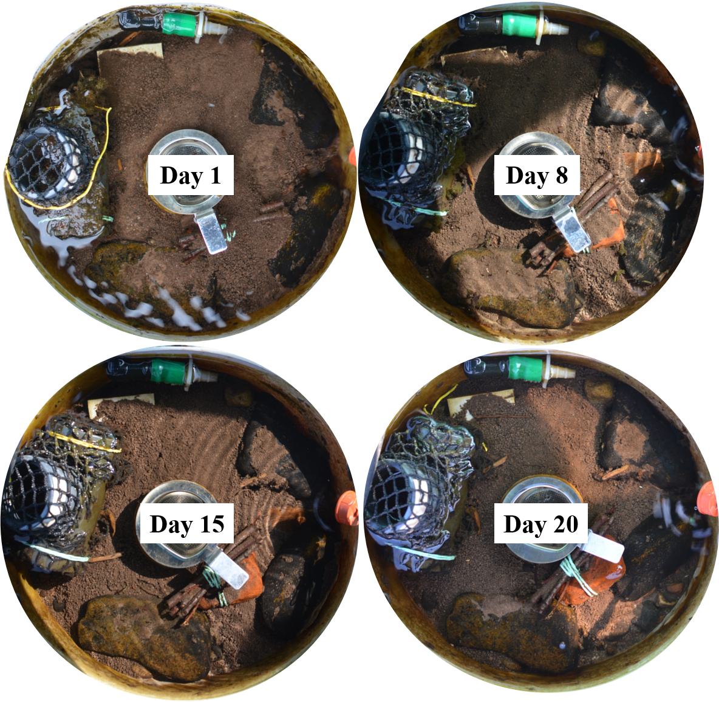

**Figure S1:** Images of exemplary channel 5 in the course of stressor manipulation of 1 until 20 days. The initial fine sediment coverage of 100 % (day 0) shifted throughout the experimental duration.

**Table S3:** Median algal coverage of the mesocosm for different insecticide treatments in percent

|  |  |  |  |
| --- | --- | --- | --- |
| **Insecticide concentration** | **day 8** | **day 15** | **day 20** |
| none | 1.8 ± 3.4 | 0.0 ± 3.0 | 0.0 ± 2.3 |
| low | 2.4 ± 1.8 | 0.7 ± 2.0 | 0.0 ± 1.0 |
| medium | 17.4 ± 5.2 | 29.0 ± 5.3 | 0.6 ± 4.0 |
| high | 78.1 ± 5.8 | 82.6 ± 6.4 | 64.2 ± 6.3 |

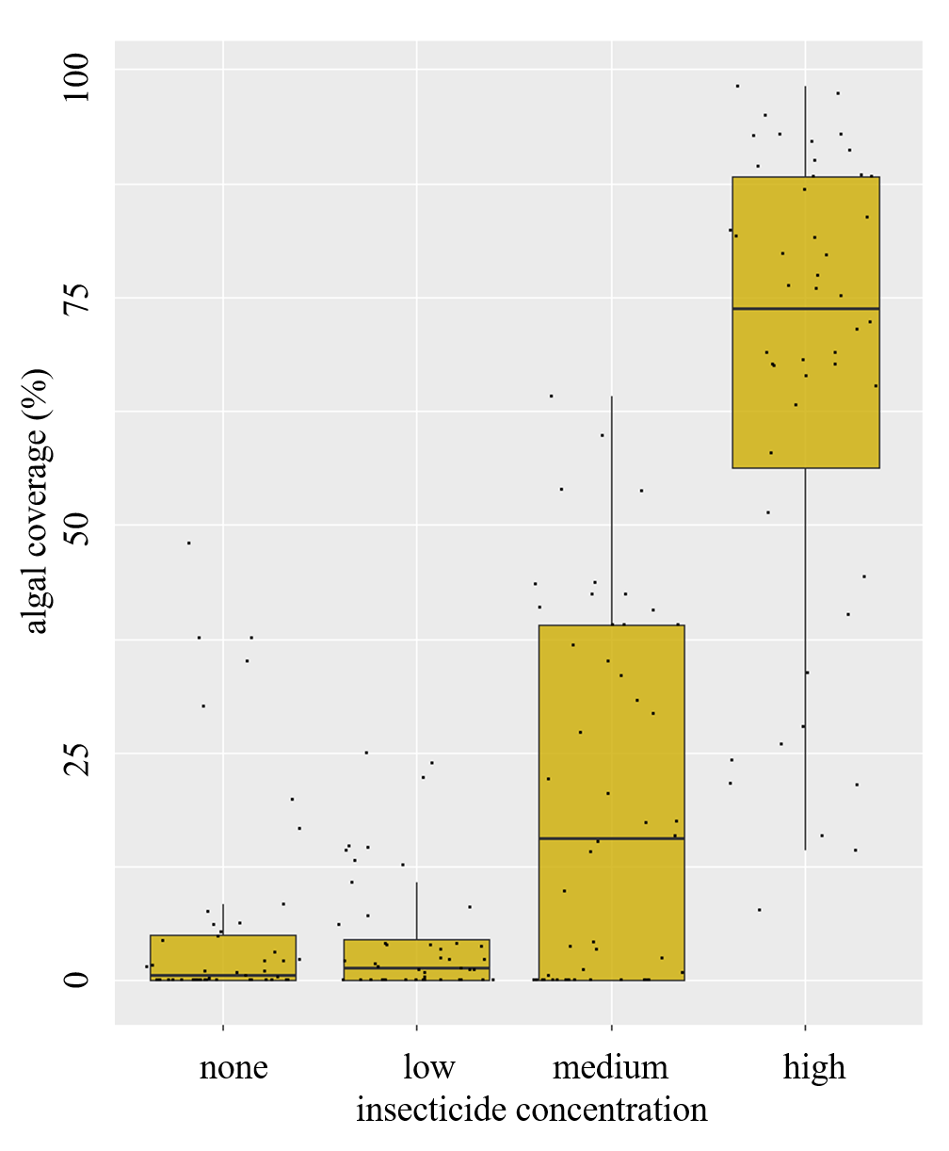

**Figure S2:** % algal cover of the mesocosm for different insecticide treatments. Measurements of days 8, 15 and 20 are combined. For medium and high concentrations algal coverage was significantly higher than for none or low insecticide concentration (Kruskal-Wallis, p =< 2.2e-16).